

BPRI2 – Smart news system

Process Report

Group Members: Rares Dan Pologea student number: 208253

Pavel Kočarian student number: 208237

Mihai Enea student number: 142529

Supervisor: VIA: Stephan Erbs Korsholm, Asbjørn Thalund Binderup

STIBO: Kim Svendsen

Table of Contents

Table of figures 3

Table of tables 3

List of keywords used throughout the project 3

1. Introduction 4

2. Team 5

2.1. Group policy 5

2.2. Team Members 6

2.3. Working Hours and Schedule 6

2.4. SWOT Analysis 8

2.4.1. Rareș Dan Pologea SWOT Analysis 8

2.4.2. Mihai Armand Enea SWOT Analysis 8

2.4.3. Pavel Kočarian SWOT Analysis 8

2.4.4. Team SWOT Analysis 9

3. Methodology 9

3.1. Waterfall Model 9

3.1.1. Requirements 11

3.1.2. System and software design 11

3.1.3. Implementation and unit testing 12

3.1.4. Integration and system testing 13

3.1.5. Operation and Maintenance 13

3.2. Component based software engineering 14

3.2.1. Component analysis 14

3.2.2. Requirements modification 15

3.2.3. System design with reuse 15

3.2.4. Development and Integration 15

4. Planning and Execution 15

5. Highlight Team Meetings 16

5.1. First highlighted team meeting 16

5.2. Second highlighted team meeting 17

5.3. Third highlighted team meeting 17

5.4. Fourth highlighted team meeting 17

5.5. Fifth highlighted team meeting 18

5.6. After the fifth highlighted team meeting 18

5.7. Sixth highlighted team meeting 18

5.8. Seventh highlighted team meeting 18

5.9. Eighth highlighted team meeting 18

6. VIA Supervisor Meetings 19

6.1. First VIA Supervisor meeting 19

6.2. Second VIA supervisor meeting 19

6.3. Third VIA supervisor meeting 19

6.4. Fourth VIA supervisor meeting 20

6.5. Fifth VIA supervisor meeting 20

6.6. Sixth VIA supervisor meeting 20

6.7. After the sixth VIA supervisor meeting 21

6.8. Seventh VIA supervisor meeting 21

6.9. Eighth VIA supervisor meeting 21

6.10. Ninth VIA supervisor meeting 21

6.11. Tenth VIA supervisor meeting 22

6.12. Eleventh VIA supervisor meeting 22

6.13. Twelfth VIA supervisor meeting 22

7. STIBO Supervisor Meetings 23

7.1. First STIBO Supervisor meeting 23

7.2. Second STIBO Supervisor meeting 23

7.3. Third STIBO Supervisor meeting 23

7.4. Fourth STIBO Supervisor meeting 23

7.5. Fifth STIBO Supervisor meeting 24

7.6. Sixth STIBO Supervisor meeting 24

7.7. After the seventh STIBO Supervisor meeting 24

8. Project Result 25

9. Reflections 25

10. References 26

11. Appendices 26

# Table of figures

Figure 1. Waterfall model 10

Figure 2. Server machine browser window 13

Figure 3. Component-based software engineering 14

# Table of tables

Table 1. Team members 6

Table 2. Team working schedule 6

Table 3. Rareș Dan Pologea SWOT Analysis 8

Table 4. Mihai Armand Enea SWOT Analysis 8

Table 5. Pavel Kočarian SWOT Analysis 8

Table 6. Team SWOT Analysis 9

# List of keywords used throughout the project

Here you will be able to find a complete list with all the key words used in this report and what they mean, ordered alphabetically. The key words will be found within the content of the report by being italic.

*Alexa* – An intelligent personal assistant developed by Amazon. The Amazon Echo ships with Alexa preinstalled.

*Alexa Skill* – see Skills.

*Alexa-enabled RaspberryPI* – A RaspberryPI device which features the Alexa intelligent personal assistant.

*Amazon Echo* – Smart speaker developed by Amazon. It is further discussed below.

*Node.js* – An open-source, cross-platform JavaScript runtime environment.

*RaspberryPI* – A single-board computer used for the server in our project. Further discussed below.

*S.N.S* – Stands for Smart News System, it is the core system name.

*Skill* – Term used by Amazon to describe any of the Amazon Echo’s functions. It is further discussed below.

*STIBO* – Stibo Systems, the company with whom the team has collaborated on the project.

*STIBO Accelerator* – Part of Stibo Systems which houses projects made in collaboration with students or start-ups. STIBO Accelerator was kind enough to offer the team guidance throughout the project, necessary materials, and an office to work in.

*STIBO Supervisor* – Kim Svendsen. He is our supervisor from the STIBO Accelerator and one of the persons who guided us throughout the project.

*URL* – Uniform Resource Locator, is a reference to a web resource that specifies its location on a computer network and a mechanism for retrieving it. It is informally known as a web address.

*VIA Supervisor* – Asbjørn Thalund Binderup. He is the first supervisor from VIA University and one of the persons who guided and helped the team from the beginning of the project period until 16.12.2016. Starting from 01.02.2017, the VIA Supervisor was now Stephan Erbs Korsholm. He has guided and helped the team throughout the final ten weeks of the project period.   
*VIA University* – The university at which the group of student in charge of the project study.

# Introduction

This report presents the process which the group of three students followed to complete their bachelor project. To find out more information about the building of the *S.N.S* project please have a look at the Project Report. In this report the focus is placed on presenting the team and how they organized themselves during the project period. The report also contains the methodology chosen to manage the flow of the project. How and why the team ended up using these methodologies can be found in this report in Chapter 3**.**

There also are chapters which present in detail the meetings the group had had with both the *VIA Supervisor* and *STIBO Supervisor*. The meetings are meant to reflect on the problems the group faced and how the problems were dealt with. The meetings also show with which supervisor the team interacted and in relation with what issues. The meetings can be found in Chapters 4, 5 and 6.

As the project ended the team decided to have a discussion on how they and their project evolved during the project period, what they achieved and what they did not. All of that can be seen in the last chapters of this report that being Chapter 8 and 9.

# Team

The group is composed of 3 members. All the members have signed a group policy that will be presented in the next subchapter, which states the working hours and the rules. All the group members have agreed to follow this group policy during the entire project period to try and fit the time frame as well as they could. The place of choice for work was the *STIBO Accelerator* because an appropriate working place has been organized for the team by the *STIBO Supervisor* and access to the technology used for this project has been granted. It is also significantly easier to coordinate the work and plan the team meetings in a work-oriented environment. Another advantage of working together at the *STIBO Accelerator* was that the group could more easily communicate, get feedback and assistance from each other or the *STIBO Supervisor* if difficulties were encountered.

The group worked well together and every member was an indispensable asset throughout the project. There were neither conflicts nor heated discussions, but some debates took place. These can be better seen in Chapter 4. During each meeting, every member had to describe what he did up until then, what is he planning to do next and what difficulties does he expect to encounter, if any. If someone had finished their task, they would move on to the next assigned task or try and help any team member in case issues where encountered. Thus, some of the more complicated tasks ended up being done in groups for efficiency purposes. After a task was completed, it was marked as done in the list of tasks and the team would move on to the next issues. This way the group ensured there would be no confusion about who is doing which task and whether tasks are finished or not.

## Group policy

* If you are unable to attend group work, you must say so immediately.
* Be prepared so that no time will be wasted on extra preparations.
* Follow the agenda for the day.
* Keep a log to avoid future confusion.
* Be dedicated to the group and the work.
* As a group member, you are responsible for your own learning process.
* Everyone must participate in team meetings (even through Skype if necessary).
* Ask for help when needed. Don’t waste time trying to do it on your own.

Consequences:

* If you fail to attend the group work without notice, you get a yellow card. At the third yellow card, you are immediately expelled from the group.
* If you do not maintain proper attitude and ethics towards group meetings you will be warned. If the situation continues, we will discuss it with you and the supervisor in order to come up with a common solution. If no solution is reached, you will leave the group.
* If you do not know how to do your part of the work, give notice to the group. If you do not notice the group, then at the third offense, you will be expelled from the group.

## Team Members

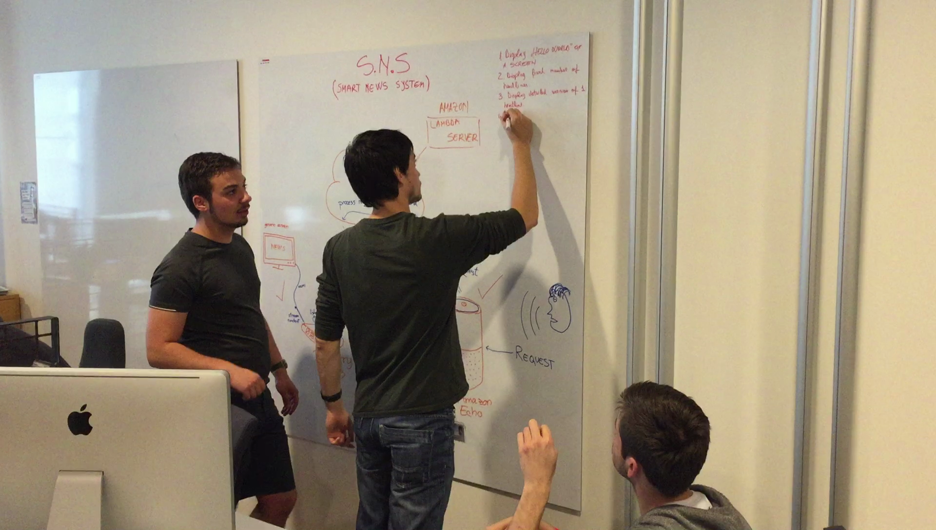

Table 1. Team members

|  |  |
| --- | --- |
| Name | Student ID |
| Mihai Armand Enea | 142529 |
| Rares Dan Pologea | 208253 |
| Pavel Kočarian | 208237 |

## Working Hours and Schedule

It has been agreed by the whole team that Monday through Friday are working days, weekends and holidays are off days. However, it is still possible to work during weekends if the team falls behind schedule or by a unanimous decision if ever proven necessary.   
Because each team member has made different choices for the upcoming 7th semester courses, the working schedule ended up looking as follows:

Table 2. Team working schedule

|  |  |  |  |  |  |  |  |
| --- | --- | --- | --- | --- | --- | --- | --- |
| Working Schedule  From: 15.08.2016  To: 16.12.2016 | Mon | Tue | Wed | Thu | Fri | Sat | Sun |
| Mihai Enea |  |  |  |  |  |  |  |
| Rares Pologea |  |  |  |  |  |  |  |
| Pavel Kočarian |  |  |  |  |  |  |  |

|  |  |
| --- | --- |
|  | Working at *STIBO* (8 hours) |
|  | Working from home (4-6 hours depending on the received homework) |
|  | Free time (can become yellow or even red depending on the team’s progress) |

By following this schedule, the group managed to attend their courses without issues and without falling behind during the project period.

In the last ten weeks of the project (01.02.2017 – 18.04.2017), the team chose to stop meeting at the *STIBO Accelerator* due to reasons such as *STIBO Accelerator* hosting a new series of groups and start-ups, which meant that there was no physical space for the team, and the fact that *STIBO* allowed the team to take home the equipment needed for the project. This way, the team met up at the local library, at school or at one of the members’ home and worked there as a group.

Thus, the working schedule for the team became as such:

|  |  |  |  |  |  |  |  |
| --- | --- | --- | --- | --- | --- | --- | --- |
| Working Schedule  From: 1.02.2017  To: 18.04.2017 | Mon | Tue | Wed | Thu | Fri | Sat | Sun |
| Mihai Enea |  |  |  |  |  |  |  |
| Rares Pologea |  |  |  |  |  |  |  |
| Pavel Kočarian |  |  |  |  |  |  |  |

|  |  |
| --- | --- |
|  | Working at the library/school/in a group (6 hours) |
|  | Working from home (4-6 hours depending on the received homework) |
|  | Free time (can become yellow or even red depending on the team’s progress) |

This new schedule allowed the team to spend more time working in a group, however this change was not because of not working in the *STIBO Accelerator* anymore, but because the group did not have courses to attend in this period. Sometimes there were days when the team was not able to meet up due to unavoidable circumstances. In those days, the group members worked from home and kept in touch over the phone or via Skype.

## SWOT Analysis

The SWOT analysis for every group member and the group as a whole can be found here.

### Rareș Dan Pologea SWOT Analysis

Table 3. Rareș Dan Pologea SWOT Analysis

|  |  |
| --- | --- |
| Strengths:   * Attentive to details * Honest * Dedicated * Creative | Weaknesses:   * Easily distracted * Fear of failure |
| Opportunities:   * Improve communication skills * Improve organizational skills * Improve confidence in own work * Gain experience with a large-scale project | Threats:   * Procrastination * Getting bored of doing the same project for a long time |

### Mihai Armand Enea SWOT Analysis

Table 4. Mihai Armand Enea SWOT Analysis

|  |  |
| --- | --- |
| Strengths:   * Energetic * Leadership skills * Quick learner * Well organized | Weaknesses:   * Report writing skills * Get bored of doing the same thing * Easily loses patience |
| Opportunities:   * Improve writing skills * Improve communication skills * Gain experience with a large-scale project | Threats:   * Health problems * Getting distracted by social media |

### Pavel Kočarian SWOT Analysis

Table 5. Pavel Kočarian SWOT Analysis

|  |  |
| --- | --- |
| Strengths:   * Technical skills * Quick learner * Creative * Ability to push things forward | Weaknesses:   * Difficult to keep focus on tasks * Difficult to balance work/social life * Report writing skills |
| Opportunities:   * Improve organizational skills * Improve writing skills * Gain experience with a large-scale project | Threats:   * Getting distracted by social media * Procrastination |

### Team SWOT Analysis

Table 6. Team SWOT Analysis

|  |  |
| --- | --- |
| Strengths:   * Well-coordinated team * Don’t give up easily * Common goal * Well-balanced team members | Weaknesses:   * Everybody has their own way of doing things * Communication is not always the best * Slow to get out of the gate when starting a new project |
| Opportunities:   * Further improve communication skills * Improve ourselves in different ways * Sharing ideas * Learning to work on large-scale projects | Threats:   * Procrastination * The research-oriented theme of the project makes it different from previous projects |

# Methodology

In the early beginnings of the project period the group discussed the possibility of using the *SCRUM* methodology because they were the most accustomed to it from the previous projects they had in *VIA University*. But after some discussions with the *VIA Supervisor* which can be found in Chapter 6.2.the group realized that it might not have chosen the best approach for their project and decided to invest some time in researching for another way. With the help of a software engineering book which the group got from one of their teachers, they figured out that a project such as theirs, which combined the use of more hardware devices to create a product, would be better organized by using Component based software engineering. After some more digging they read that the Waterfall model goes hand in hand with the Component based software engineering model is used to dictate the work flow from an implementation/software point of view as when the Component based software engineering process focuses more on the choosing the right hardware components based on the give hardware requirements which can be found in the project report in chapter 2.1.4.

## Waterfall Model

As mentioned earlier this method was used to dictate the work flow of the project and as the picture below shows how the process starts and flows downwards from one step to another while they are completed forming the waterfall.

For more theoretical information regarding the Waterfall model please check [1], as this report’s main focus is to present the work flow of the team during their project period.

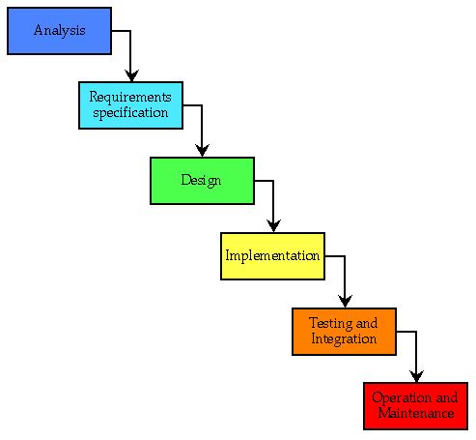

Figure 1. Waterfall model

The team started with the *analysis* part in which they had to discuss with their *STIBO Supervisor*, in order to establish what was the group audience that the product was targeting and what were the advantages that they should be looking for in order to make the project more useful for the potential clients than what the market already had to offer.

Pleased by the team’s enthusiasm and serious attitude regarding the project, the *STIBO Supervisor* explained his vision for the project. From the very beginning, the *STIBO Supervisor* let the group know that every idea and plan that he will have with this project can, if proven necessary, be modified to fit their needs for the standards of *VIA University*.

The team was then introduced to the *Amazon Echo*, a smart speaker which ships with *Alexa* preinstalled, an intelligent personal assistant capable of performing multiple tasks. The device is further explained in *Appendix B - Amazon Echo Description*. After growing accustomed with the *Amazon Echo*, it was obvious that it lacked the feature to be used to broadcast video feedback on a screen.

After a few days of planning they arranged a meeting with their *STIBO Supervisor* to discuss a list of requirements needed to complete this project. The discussion made it clear that a period of research was necessary. This came as a time set back due to fact that all 3 group members had the same classes for the past 3 years, which means that they mostly shared the same knowledge and when it came to doing research all of them had to put in approximately the same amount of effort. This proved useful since all group members thus had full knowledge of the project both software and hardware requirements.

### Requirements

After making a list of requirements which can all be found in the Project Report, Chapter 2.1., the group met with the *STIBO Supervisor* to make sure that they were on the right track. He was pleased with their results and suggested the team move forward to the core system design phase.

After getting the approval from the *STIBO* *Supervisor*, the team members arranged a meeting with their *VIA Supervisor* to get feedback from there as well and then advance with the process. Fortunately for them, this meeting went in a positive way as well even though their *VIA Supervisor* was not yet sure what the core system will look like, but that was acceptable seeing as they did not have time to take it into consideration yet, but were planning to do so as soon as possible. More details about the requirements can be found in the Project Report, Chapter 2.1.

### System and software design

With the requirements set, the group moved on to designing the core system. The core system was going to be made from multiple hardware devices which work together to give the expected results. It was clear for the group what the project outcome should be but the problem was choosing the hardware which would best fit the project’s needs. More details about each particular component which was taken into consideration for this project, as well as the reasons for doing so, can be found in the Project Report, Chapter 3.2.

Before reaching the implementation point, one of the group members found a very interesting idea relating to the *Amazon Echo*. He found out that *Alexa* can be directly implemented on the *RaspberryPI* and the idea was approved by the *STIBO Supervisor*. The reasoning behind this was that the project needed a hardware device which could connect to a generic display through HDMI, which the *Amazon Echo* could not, but the *RaspberryPI* could. So, by making the *RaspberryPI* act both as the *Amazon Echo* and the as the device connecting the *Amazon* *Echo* to the screen, the group could have replaced the *Amazon* *Echo* completely and use only one device that would make the product more user friendly.

While building the *Alexa enabled RaspberryPI*, the team realized that this *Amazon Echo* replacement needed extra hardware components attached to the *RaspberryPI* such as a microphone, a speaker and a push-to-talk button. Although the first two components were easily purchased and attached to the *RaspberryPI*, when it came to attaching the button it proved more difficult than expected. To work around the problem, the team created a *JavaScript* button to test the *Alexa-enabled RaspberryPI*, and to prove to the *STIBO Superv*isor that the device worked.

Unfortunately, the *Alexa-enabled RaspberryPI* ended up not being useful for the team from a few points of view such as quality of the peripheral components. The most important reason it was declined from the project, however, was due to the push-to-talk button which much detracted from the value of a product with which the user can interact hands-free, such as the *Amazon* *Echo*.

Thus the group ended up with having to make a choice between the *Amazon Echo* and *Google Home*. More information about this can be found in the Project Report, chapter 3.2.

Towards the end of the project period the team concluded that despite having several key features which would be desired in a hands-free system, the *Amazon Echo* and *Alexa* could not be used as the piece of functionality to be added to the *Amazon Echo*, called *Skill*, first had to be approved by *Amazon.com*. However, *Amazon.com* refused to approve the *Skill* without having access to the full application first, which made it very difficult for the team to continue work on the *Skill*. Thus, the team decided to use a different solution for the interpretation of audio commands and ended up using the *Speech API* (the *Speech API* is further documented in the Project Report Chapter 3.2.1.). As a result, the only hardware components that the team uses for the project are the *RaspberryPI* and a generic, HDMI-enabled screen.

### Implementation and unit testing

The first entry point of the system is the user voice input picked up by the *Amazon* *Echo*. When a person gives a voice command to the *Amazon Echo*, a specially designed function on the *Alexa* voice service called *Skill* transforms said sentence into a string, appending it to a *HTTP* request which is then sent to the end-point defined in the *Skill* configuration. An end-point *URL* is then made to point to the *Node.js* server running on the *RaspberryPI*, where received commands will be processed and the appropriate function will be executed.

The generic screen presented in the picture below has an open HTML window, which changes the content of a window depending on what is the *Node.js* server emitting. In the picture the *Node.js* server is emitting sports news.

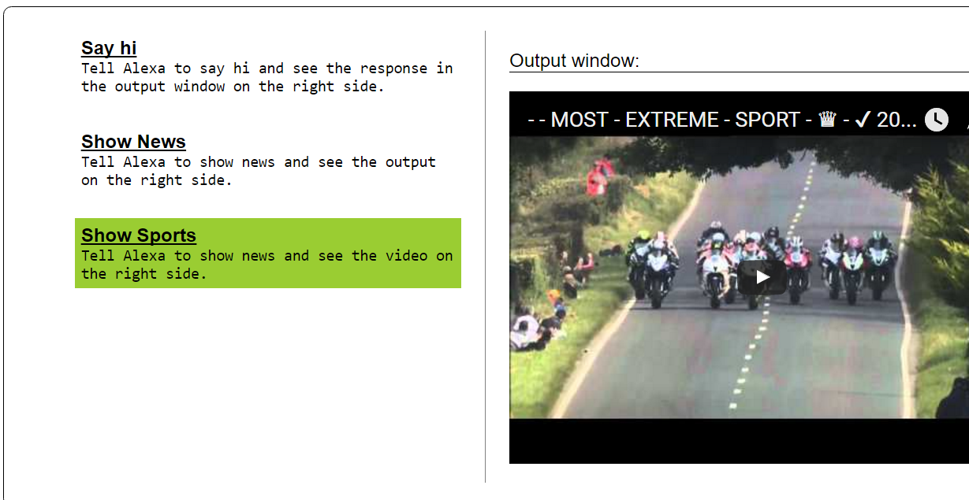

Figure 2. Server machine browser window

More information about the implementation and testing process can be found in the Project Report Chapters 4 and 5.

### Integration and system testing

The individual program units or programs are integrated and tested as a complete system to ensure that the software requirements have been met. After testing, the software system can be delivered to the customer. In our case the system is delivered to *VIA University* for evaluation. More detailed information about how the test where conducted and which where the results can be found in the Project Report, Ch. 5.

### Operation and Maintenance

Normally this is the longest life-cycle phase. The system is installed and put into practical use. Maintenance involves correcting errors which were not discovered in earlier stages of the life cycle, improving implementation of system units, and enhancing the system’s service as new requirements are discovered. Since this is a bachelor project and no actual clients have been assigned to use the system and give feedback, so that the team could correct hidden bugs or errors, the team never reached this phase. Operation and maintenance are mentioned because the *STIBO Supervisor* wanted to send the project to a group of people so that the project would go through this phase as well, but too little time was left and the team decided to skip this stage instead of starting it and risking running out of time. The system was only tested using unit tests and a full system test to be sure that the final result is correct according to the requirements.

## Component based software engineering

In most software projects, there is software reuse to a certain degree. This usually happens when people working on the project know of design or code which is similar to what is required for the project. The developers then look for these, modify them as needed and incorporate them into their system. From an evolutionary point of view reusing components is essential for rapid system development project such as this one.

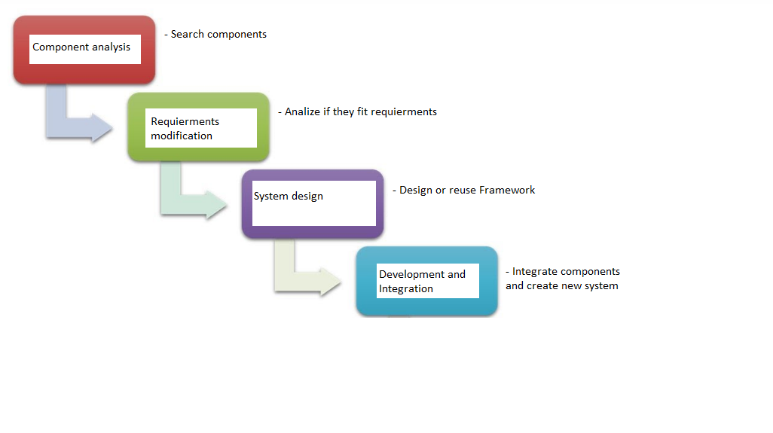

Figure 3. Component-based software engineering

### Component analysis

Given the requirements specification, components to implement were sought so that they adhered to the specifications. Usually there is no exact match, and the components that may be used only provide some of the functionality required.

In the beginning, the only hardware component the team knew they were going to use was the *Amazon Echo*. Even then, research was needed to make sure that there is no better suited hardware available on the market.

After more research, the team realized that they will need a device capable of handling a webserver in order to receive the information from the Amazon Echo, so they chose the *RaspberryPI 3*. Another option besides the *RaspberryPI* was the *Intel Compute Stick*, however the RaspberryPI was better suited because of a number of reasons explained in detail in the Project Report, Chapter 2.1.4.

For the screen there was no particular requirements, except for the need for an HDMI input. Thus, any HDMI-capable screen is fit for the project. A more thorough explanation is available in the Project Report, Chapter 2.1.4 or Appendix B.

### Requirements modification

During this stage, the requirements were analyzed using information about the components that have been discovered. They were then modified to reflect the available components. Where modifications are impossible, the component analysis activity may be re-entered to search for alternative solutions. Fortunately for the group the components which were found fit the requirements perfectly. Thus, the component analysis activity was not re-entered. A more detailed explanation of the requirements can be found in the project report, chapter 2.1.

### System design with reuse

During this phase, the framework of the system is designed or an existing framework is reused. The team members took into account the components that are used and organized the framework according to this. In case the reusable components are not available, some new software may have to be designed. In the team’s case, there was no need other new software because the components which they needed where available. More about this can be found in the project report chapter 2.1.4.

### Development and Integration

Software that cannot be externally produced is developed and the components are integrated to create the new system. System integration in this model may be part of the development process rather than a separate activity and thus more information about it can be found in the project report, chapter 4.

# Planning and Execution

The planning for this project took place at the *STIBO* *Accelerator*, to make sure that the team is on the same page with the *STIBO* *Supervisor* when it comes to designing and developing the *Smart News System*.

During the execution phase, a communication channel with both *VIA* and *STIBO* *Supervisors* was always open. Communication with the *STIBO* *Supervisor* was especially helpful, as it was easy for the team to get feedback for any idea they had, usually on the spot, thus saving time.

The planning and execution phase for this project is characterized by periods of research mixed with periods of implementing functionality. The periods of research were needed due to the *Skills*, which is a way of adding functionality different from what the team has learned in school.

To aid with making progress during this phase, a list of requirements was made, then each team member was assigned to a series of tasks either software or hardware related. The group made sure to always plan things ahead and always followed the same pattern for meetings.

Throughout the planning and execution phase the team followed a three-phase plan which allowed them to come up with solutions which satisfied both the *STIBO* and *VIA* *Supervisors*. The team would first have a meeting on their own and discuss all the possible problems that might occur, as well as the solutions that they could come up with. Then in the second phase the team would consult with the *STIBO Supervisor* to make sure that the solutions found are still within the scope of the project. As for the third and final phase, the team would book a meeting with the *VIA Supervisor* in order to discuss their latest findings and get feedback.

The only period in which the team followed a different plan regarding planning and execution was towards the end on the project period, when the team switched from using the *Amazon Echo* to the *Speech API*. While the switch was an appropriate choice for the team and the project, the team stopped having meetings with the *STIBO Supervisor* since *STIBO* was no longer interested in the project because the team was not using the *Amazon* *Echo* anymore. In this period the team would have a meeting among themselves and discuss possible problems and solutions. Afterwards, the team would consult with the *VIA Supervisor* to get feedback. After receiving feedback, the team would then decide what is the appropriate course of action and start working.

# Highlight Team Meetings

The team agreed on having group meetings during the workdays. Since the only day when all three of them are able to come to the *STIBO* *Accelerator* is Monday, it was agreed that Monday will be the primary meeting day. During the primary meeting day, the team will try to plan, discuss and handle as many tasks as possible. The rest of the days the meetings would be held with the help of Skype voice calls in order to discuss what each of the team members did, will do, and what problems they have encountered while attempting to solve the tasks.

## First highlighted team meeting

The first group meeting took place at the *STIBO* *Accelerator* and the team alongside the *Stibo* *Supervisor*. During this meeting it was decided that it would be wise to start the project off by doing research. Seeing as there were no similar projects previously attempted, the research had to done both in the software as well as the hardware area. Thus, at the end of the meeting everyone agreed that each team member should have both hardware and software tasks assigned for the research period so that more ground could be covered. The research was divided as so:

Mihai - hardware research: Amazon Echo, Raspberry Pi 3, Alexa Pi (Voice Service on RaspberryPI 3);

- software research: Node.js framework, JavaScript;

- methodology: Waterfall model, Component based software engineering;

Pavel - hardware research: Amazon Echo, Raspberry Pi 3, Amazon Fire Stick;  
 - software research: Node.js framework, JavaScript;

- methodology: Waterfall model, Component based software engineering;

Rareș - hardware research: Intel Compute Stick, Apple TV, Amazon Echo, RaspberryPI 3;

- software research: Node.js framework, JavaScript;

- methodology: Waterfall model, Component based software engineering;

## Second highlighted team meeting

This meeting took place after the first supervisor meeting. In this meeting, the team realized with the help of the *VIA Supervisor* that they did not have a well-defined core system. It was decided that an illustration of it would be useful in order to give the readers a better idea of what the project is about. During the same meeting the project was given the official name of *Smart News System*, or *S.N.S*.

## Third highlighted team meeting

During this meeting the team worked on the Introduction and Analysis parts of the Project Report and came up with a structure for the Project and Process Report so that the team can start writing report sections as they went along, allowing the team to write both code and documentation at the same time.

## Fourth highlighted team meeting

In this meeting, some of the final tasks have already started to be handed out to the team members, as the time to wrap things up was closing to an end. The system was capable of displaying “Hello World” using the *Amazon* *Echo* as an input device. Furthermore, the system was also capable of displaying one news headline of the “News” kind and one news headline of the “Sports” kind, while also being able to switch between them. The news headlines were displayed in the form of videos hosted on YouTube. Effort would also be constantly put into documentation to be sure that the team members did not leave any important details out.

## Fifth highlighted team meeting

In the fifth team meetings, having the development part up and ready, the group focused all their remaining time into ensuring that the documentation is up to standards. They made sure to take their supervisors advice into consideration and put reasoning behind what they were writing as well as references pointing to their rightful owners.

## After the fifth highlighted team meeting

After the first deadline (16/12/2016), the team was examined on the project on 24/01/2017. After the examination is was decided that the team had some issues with the project and the team was given an additional ten weeks starting on 01/02/2017 to sort out the respective issues. Moreover, the VIA Supervisor changed because a different teacher expressed interest in the project and offered himself to be the new VIA Supervisor.

## Sixth highlighted team meeting

This meeting was the first highlighted team meeting to take place after the initial deadline and before the first meeting with the second VIA Supervisor. The meeting was dedicated to figuring out the course of action for improving the report. The examiner’s feedback started with the Project Report, due to its unmet page requirement. The VIA Supervisor pointed the team in the right direction starting with the Introduction and Analysis. The feedback received was taken into consideration when the team members came up with improvement ideas.

## Seventh highlighted team meeting

This highlighted team meeting took place before the ninth VIA Supervisor meeting. In this meeting the team members briefly discussed the modification that needed to be made to the Project Report, then brainstormed ideas for added functionality. The main idea the team came up with was connecting a database to the system and implementing several features that would make use of the database, such as adding a certain video to a list of favorite videos. The list of favorite videos would be stored locally on a database. The project’s name was also changed to “Hands-free web interface”, as this name is more appropriate when taking into consideration the actual functionality of the system and that it has changed its focus since choosing the last name.

## Eighth highlighted team meeting

The eighth highlighted team meeting took place before the eleventh *VIA Supervisor* meeting. Besides the usual topics of discussion, such as the reports, this highlighted team meeting was dedicated finding a replacement for the *Amazon* *Echo*, since *Amazon.com* did not want to approve the *Skill* the team developed until after the team sent the whole system to *Amazon.com* for examination, which would make the development process very lengthy and difficult. The team instead looked for alternatives and settled on the *Speech* *API*, an API which would handle the audio to text conversion. The API would be integrated in the system and made to work together with the *YouTube* *API* to provide the desired functionality.

# VIA Supervisor Meetings

Besides the group meetings, there were also the guidance and feedback meetings held with a designated supervisor from both *VIA* and *STIBO Accelerator* in order to help the team get past the difficulties that they might have encountered and make sure that they are on the right track with their project. In this chapter, the meetings with the *VIA Supervisor* have been emphasized.

## First VIA Supervisor meeting

Date: 14/09/2016

After the first supervisor meeting the team realized that they had fallen behind schedule with documentation, but this was because a choice was not yet made on a core system and thus more time had to be spent on research to come up with a solution.

## Second VIA supervisor meeting

Date: 23/09/2016

During the period between the first and second meeting each team member shifted more of their focus to the documentation part and after having a few discussions between themselves and with the supervisor, they decided to use a different approach for the methodology. The team chose the waterfall model used in combination with the component-based software development due to the nature of this project in which the use of extra already made hardware components has been a requirement from the company with whom the project is made in collaboration, *STIBO Accelerator.*

## Third VIA supervisor meeting

Date: 4/11/2016

The third meeting was held mostly so that the team could get a quick feedback on the project and process report. Besides a few changes and corrections, the reports were well made. The team knew at this moment that they kept the work on the right track. Some of the changes and suggestions that they have been updated with would be as never to use the name of the supervisor in the reports but the title that he was given, they should keep the reports presented in 3rd person and to make sure that no articles or documents are referenced without appearing in the actual report. After the meeting the team got straight back to work and started bringing both reports to their final forms.

## Fourth VIA supervisor meeting

Date: 24/11/2016

In the fourth meeting discussion about how the report should be written correctly and academically started. One of the first issues that came to the supervisor’s attention was the Abstract chapter found in the Project Report. It was apparent that the team had a different idea of what an abstract is, but the issue was solved easily due to the supervisor’s experience and way of explaining that helped the team understand that an Abstract is more like a summary of the whole project, and not just a summary of the product itself. The team was also encouraged to explain in more detail the targeted audience groups as well as the reasons why the is project a good idea and why was the functionality implemented in this way. This came as a great advice, because the group already had the necessary information to satisfy these requests.

Another suggestion was that many words which the team used might be very confusing, so other persons that might want to further develop the project might have a hard time understanding the documentation. Thus, the team came with the solution of adding a list of keywords at the beginning of each report, to make sure that all readers will be able to understand exactly what is the reports refer to, regardless on context.

## Fifth VIA supervisor meeting

Date: 9/12/2016

As the deadline was nearing the team only wanted feedback and general information about the font size, indentation, and other trivial issues. Due to the small amount of questions that the team needed answers to, everyone agreed that the meeting should be held through e-mail and that it would be a good idea to have one final wrap up meeting.

## Sixth VIA supervisor meeting

Date: 13/12/2016

The final meeting with the first VIA supervisor before the first deadline was straight forward considering the time remaining until the first deadline which was on 16/12/2016, so the *VIA Supervisor* tried to give the group some final advice. He started with pointing out how important references are for the reader, which may not have all the knowledge that the group members have, and the second important part was the missing reasoning behind some of the explanations found in both reports. He considered them to be too broad. The team understood where they made the mistakes and agreed to try and correct them. The last advice was to make sure that the report is as consistent as possible and there should be as few grammar mistakes as possible.

## After the sixth VIA supervisor meeting

After the first deadline (16/12/2016), the team was examined on the project on 24/01/2017. After the examination is was decided that the team had some issues with the project and the team was given an additional ten weeks starting on 01/02/2017 to sort out the respective issues. Moreover, the VIA Supervisor changed because a different teacher expressed interest in the project and offered himself to be the new VIA Supervisor.

## Seventh VIA supervisor meeting

Date: 06/02/2017

The seventh VIA supervisor meeting was the first supervisor meeting the team has had with the second *VIA* *Supervisor*. In this meeting were discussed the first measures that need to be taken to solve the problems the project had. The measures the group and the *VIA Supervisor* agreed upon were overhauling the Introduction and Analysis parts of the Project Report, adding some scenarios so that a potential reader of the Project Report can get a better idea of what the project is about, and adding hands-free login as a system feature.

## Eighth VIA supervisor meeting

Date: 21/02/2017

The eighth VIA supervisor meeting was spent further discussing about the Introduction and Analysis parts of the Project Report. The Design chapter was also discussed. The main problem of the respective chapters was that when the team had written them they did not consider that some things are not as clear to a potential reader as they are to the team. When working on the project, the team had interacted mostly with people with an IT background, people who are familiar with certain processes and technologies typically encountered when working in IT. Thus, the chapters in discussion were modified so that ideas were expressed more clearly and in a more easily understandable way.

## Ninth VIA supervisor meeting

Date: 28/02/2017

In this meeting the team further discussed the Project Report with the *VIA Supervisor*, and talked about adding further features to the system. It was decided that the use cases would receive more attention, and that the team will come up with a way to integrate playlist functionality and database connection to the system.

## Tenth VIA supervisor meeting

Date: 20/03/2017

This meeting was dedicated to discussing about a problem the team encountered: the integration on the *Amazon* *Echo* and *Alexa* into the system. Since *Amazon.com* would not give permission to the *Skill* before receiving the whole, functioning system and the fact that the team could not come up with a functioning system without *Amazon.com* giving permission to the *Skill*, it was decided that the team would research a different way of tackling the problem of recording and converting audio into text.

## Eleventh VIA supervisor meeting

Date: 28/03/2017

In this meeting the team informed the *VIA Supervisor* that they had come up with a different way to convert audio into text: using the *Speech* *API*. Discussions were had about how to document all the time previously spent unsuccessfully trying to make the *Amazon* *Echo* work as an integral part of the system. Because the team felt that it was important for a reader of the reports to know all the problems the team encountered and all the effort the team has put in thus far, the team together with the *VIA* *Supervisor* decided to keep all the documentation regarding the *Amazon* *Echo* and *Alexa* and simply document the *Speech* *API* alongside it.

## Twelfth VIA supervisor meeting

Date: 06/04/2017

During this meeting the team showed the *VIA Supervisor* the progress made since the last meeting with both the documentation and the system itself. The team succeeded in showing the *VIA Supervisor* a working prototype of the audio to text conversion. The *VIA Supervisor* showed himself satisfied with the progress and discussed with the team about the Process Report and the modifications that need to be made to it.

# STIBO Supervisor Meetings

As it was described in the beginning of Chapter 6, to help the team get through with this project, supervisors have been assigned from both *VIA* and *STIBO*. This chapter will have its focus on the meetings held with the *STIBO Supervisor*.

## First STIBO Supervisor meeting

Date: 29/9/2016

The first meeting which took place at the *STIBO* *Accelerator* was also the first day when they got there. After an introduction of the *STIBO* *Accelerator* area, the groups that were already working there and the whole *STIBO* facility, a meeting about the project was held. In this meeting, they have discussed the *S.N.*S project. The discussion was merely introductory, but even then, an idea was defined on how they will start their project and that there was research on the hardware to be done. The results which they would get would influence the way they would proceed with choosing the hardware and implementing the software.

## Second STIBO Supervisor meeting

Date: 17/10/2016

In the second meeting at the *STIBO* *Accelerator*, all the research done has been carefully analyzed and the course of action was decided. The team would try to emulate the *Amazon Echo* onto the *RaspberryPI* thus creating a cheaper and more accessible *Amazon Echo*. After that they would connect the newly built *Alexa-enabled Pi* to a screen and start working on software implementation.

## Third STIBO Supervisor meeting

Date: 31/10/2016

The third meeting started with a bit of disappointment due to fact that the *Alexa-enabled Pi* was successfully created, but unfortunately *Amazon* offered only a trial version of the *Alexa* voice services so the team could not properly make use of the set of pre-owned *Skills* to implement their functionality. Due to this issue a new course of action had to be made. So, the team decided to use the *Amazon* *Echo* itself as a component to this project, even if it meant losing the time spent to make the *Alexa*-*enabled* *Pi* to work.

## Fourth STIBO Supervisor meeting

Date: 7/11/2016

In this meeting two new components where presented to the team as a potential replacement candidate for the *RaspberryPI* and these where the *Intel* *Compute* *Stick* and *Amazon* *Fire* *TV* *Stick*. The idea behind them was that they possessed portability and accessibility which would outshine the *RaspberryPI* and had the potential to become a better peripheral component to use in the project. The team started doing research on the suggested hardware components.

## Fifth STIBO Supervisor meeting

Date: 14/11/2016

The highlight of this meeting was the fact that both *Intel* *Compute* *Stick* and *Amazon* *Fire* *TV* *Stick* where declined as replacements for the *RaspberryPI* mostly due to performance issues but also scalability in which the *Amazon* *Fire* *TV* *Stick* lost from the start, as it was impossible to add functionality to it. With that in mind everyone agreed that the best choice would be to finish the implementation using the components that where already chosen and start focusing more on documentation due to deadlines. Also, possible futuristic and out of scope requirements were discussed. An idea worth mentioning is a meeting with a connection *STIBO Accelerator* has at TV2, one of Denmark’s public TV stations, in order to feature content from TV2 on the *S.N.S.*

## Sixth STIBO Supervisor meeting

Date: 5/12/2016

In this meeting only details had to be discussed and at this point the team naturally asked for feedback regarding what they have achieved up until then. They were proud to find out that from *STIBO’*s point of view they did a great job with the project and not only that, but managed to create a product which later *Amazon* will develop a less complete and scalable version of. This proved that the idea for the project was indeed a very good idea and addressed a large group of potential clients thus proving its value as well.

## After the seventh STIBO Supervisor meeting

After the sixth STIBO Supervisor meeting the team stopped working on the project from 16.12.2016 until 01.02.2017. When work on the project resumed, in the beginning the team did not have meetings with the *STIBO Supervisor* because the team was waiting for a response from *Amazon.com* regarding the *Skill*. Afterwards, when the team decided to use the *Speech API* instead of the *Amazon Echo*, *STIBO* were no longer interested in the project. As a conclusion for the team’s relationship with *STIBO*, *STIBO* was happy with what the team had done with the project, but the final version (the version which does not feature the *Amazon* *Echo*) posed no interest to *STIBO*.

# Project Result

The result reflects accurately what the team wanted to achieve. Functional requirements of high, medium and low importance were all implemented. Much of the team’s efficiency is owed to the fact that all the team members have previous experience regarding team projects, which helped improve communication between team members, improved time estimates when it comes to individual tasks and improved the organizing skills of the team overall. Other reasons why the project was successful are the chosen methodology, which fits the purpose of the project very well, and the way the tasks were chosen. The way the team has done the project, the tasks follow a natural progression, the high priority tasks effortlessly leading towards the medium priority tasks, which, in turn, lead to the low priority tasks.

# Reflections

All team members are satisfied with the outcome of the project, however there were some drawbacks which were successfully overcome. One of the most important of the drawbacks is that the speed with which the project advanced was not always constant, which led to temporary losses of motivation.

Another one of the drawbacks was that since the project aimed to produce a solution which has not been attempted by anyone, unique problems were encountered during development. The problems have been successfully solved, however, both the problems and the research periods which were necessary due to the nature of the project temporarily slowed down development. Added to this is the fact that the team was initially familiar with hardware-oriented development, which meant that time was lost at the beginning of the project to do research on methodology. The time spent researching the methodology has since paid off, as the team saved time throughout the project period by being focused on the tasks at hand.

Besides previous projects from which team members gained experience which helped with the project, a very important factor which improved the team’s productivity was that *STIBO* *Accelerator* has provided the team with a good working environment, and the *STIBO Supervisor* has been very helpful by providing nearly continuous feedback on the team’s progress, coming with relevant suggestions.

Overall, the project has much potential to be continued and there are many ways in which the solution can be further improved given the necessary time. The team considers the project to be a success and the whole project period has been a positive experience.

# References

[1] - Ian Sommerville. (2004), Software Engineering*.* Seventh Edition. Pearson Addison Wesley, chapter 4, p.65 – p.83

# Appendices

Appendix A – Alexa-enabled RaspberryPI

Appendix B – Description for all hardware components considered in this project

Appendix C – Low Priority and Out of Scope

Appendix D – All Diagrams and Descriptions